Run Boy Run: An Obstacle Avoiding 3D Game

(January 2020)

Iqra Farooq Malik1, Tehreem Sultan2, Rana M. Ibrahim3 and Muhammad Abdullah Hayat4  
1,2,3,4 Undergraduate Students, Software Engineering, NED University of Engineering and Technology, Karachi, Pakistan.

***Abstract*—*Computer gaming is a key component of the rapidly growing field of software engineering as well as the entertainment industry. Development of an advanced game provides exposures to the real-world side of software engineering that they are typically shielded from in the standard computer class. Practical issues such as geometric modeling, rendering, collision detection, character animation, and graphical design are dealt with during the development of an advanced game. This paper breaks down an advanced game into various components that are used and suited for the project built. Also, it deals with the modern tools used for the development of the game RUN BOY RUN.***

*Key Words*— Unity Engine, 3D Game Development, Obstacle Avoiding Game, Blender.

# INTRODUCTION

RUN BOY RUN is an Adventure Obstacle Avoiding Computer 3D game developed in Unity, by team CODE BLOODED. All the functionalities and specifications of the project are explained in detail in this paper.

The project name is RUN BOY RUN – 3D Game. “RUN BOY RUN” is so because the music in the game is a song named ‘Run Boy Run’ so this is a perfect match. “3D” represents the 3D model of the characters and environment which will be used. The software will make the user be able to play an obstacle avoiding, addictive game. While playing the game, the user runs on a path and collects boosters and coins while its score is continuously increasing was its runs forward. The end-product will run on 64-bit Windows PC for the people who want to access the product through desktop and laptop computers. The user will be able to change its directions or lanes by the arrow and direction keys.

# LITERATURE REVIEW

There are different research papers that were considered during the development of this project. Various adventure-based obstacle avoiding games have already been developed. So, the research papers along with already built similar projects were used for guidance during the development.

“Critical Success Factors to Improve the Game Development Process from a Developer’s Perspective” [1] discusses the complex processes and factors for the successful development of good-quality games. The other research paper entitled “Game Design Research” [2] discusses the notion of game designs, it also predicts some stuff about the future of electronic-gaming (e-gaming). “The Application Of 3d Technology in Video Games” [3] tells that all in all the application of 3D technology in video games has become more and more extensive and common as well so the game design should be based on changes in times and need of gamers. “Visual Attention in 3D Video Games” [4] discusses the importance of visual effects on the user, it also explains that the gamer’s psychology can be changed by the visual graphics of the game. “The Investigation on Using Unity3D Game Engine” [5] and “Research on the Application of Products based on Unity3D” [6] both discusses the development of game using UNITY, both 2D and 3D game development are discussed in these research papers. In the paper entitled “Computer Parametric Designing in Blender for creating 3D Models” [7], the process of designing sample 3D models as well as parametric construction of different geometric complexity has been closely followed using Blender software.

# METHODOLGY

Our game “run boy run” can be described in a general way as a 3D single player obstacle avoiding game in which character runs on the track and avoid obstacles. Its development is done by following the “waterfall model” in which development of one phase starts only when the previous phase is complete.

## System Architecture

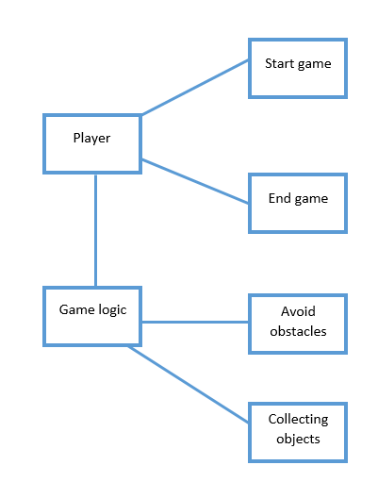Our game logic revolve around the player where after initializing the game player needs to avoid all obstacles or hurdles by moving the character left or right whereas player will also need to collect the objects or power ups to increase the total score while the game will keep running unless the character strikes with any obstacle.

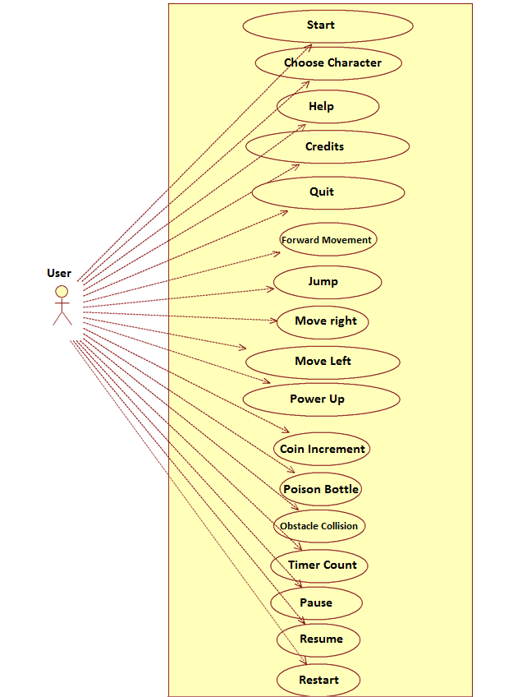

Figure 1-block diagram

## System Design

In system designing phase we have worked on modeling of objects by using Blender these objects include obstacles, diamonds, coins and poison bottles and also collecting of environment material and characters using unity asset store these material includes runway, trees and water. Score counter and coin counter is designed with the help of unity UI system.

### Use Case Diagram

Figure-2 shows all the possible functions that a user can perform in the game so our game is designed on the basis of one actor “user”.

Following are the main functions that user will perform to move the character.

Figure 2-use case diagram

* Move Left: User can move the character to the left side by pressing left arrow or ‘A’ key.
* Move Right: User can move the character to the right side by pressing right arrow or ‘D’ key.
* Jump: User can make the character the character jump by pressing up arrow or ‘W’ key.

### State transition Diagram

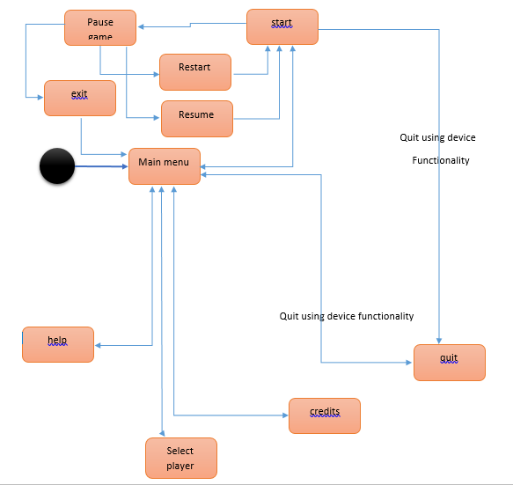This diagram shows all the possible states of our game.

Figure 3-State transition diagram

### User Interface

The game main menu page will serve as an interface for the user. In the designing of main menu we have used Unity UI system that helped us to add different types of texts whereas buttons are also used in the process of designing.

Following are the buttons name and functionalities that are designed in the main menu page.

* 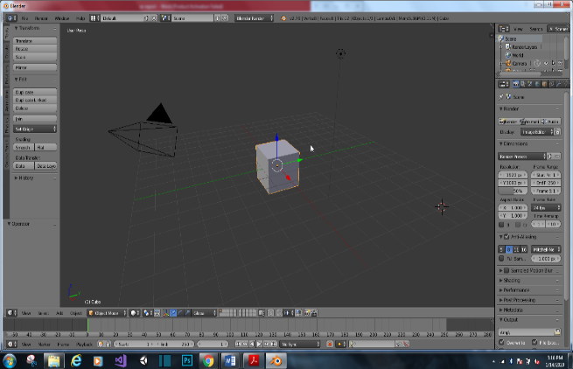Start – starts the game
* Help – instructions on how to play
* Credits – developers and team name
* Select player – to select character
* Exit – to quit the game

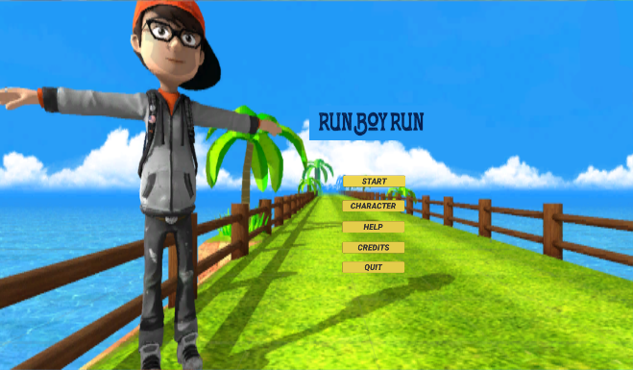

Figure 4-User interface

## Tools and Technologies Used

Following software have used in the making of our game

* Unity
* Blender
* Visual studio

### Unity

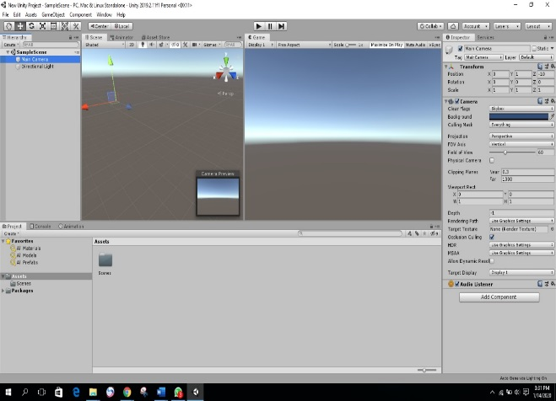Unity game engine is an IDE (integrated development environment) which is used to make 2D games, 3D games and applications. Unity also provide features like animation system, UI system and particle system etc. it is a cross platform which means that application for all types of platforms like android, IOS can be developed with the help of unity

Figure 5-Unity interface

### Blender

Blender is an open source 3D computer graphics software which is used for 3D modeling, animation, texturing, smoke simulation, rigging, and texturing, fluid, and video editing. It can also be helpful in making interactive applications .Blender also possess its own engine and it can be extended to the third party render engines.

Figure 6-Blender interface

### Visual studio

Microsoft visual studio is an IDE (integrated development environment). It is used to develop different computer programs, web apps, as well as websites and mobile apps. Visual studio supports 36 programming languages. Its built in languages include C, C++, C#, F#, Visual basic.NET, JavaScript etc.

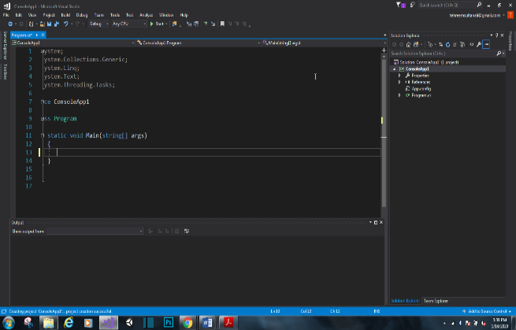Figure 7-Visual studio interface

## Implementation

In making of our game we have made different scripts for each functionality that is related to character or objects. All these scripts are being made in C# with the help of visual studio.

### Construction of Base Level or First level

In the construction of base level of the game following steps are being followed.

* We first place the character on its decided position and then player movement script is being made in which we set character speed and its movement of left, right and jump.
* The scripts for of all the power ups which includes diamond and coins is being made in a way that these power ups will help in increment of score. In the setting of diamonds unity particle system is also used by which special particle effect is shown whenever character collects the diamond.
* Obstacles coding is done in that way whenever character hit an obstacle the game will restart immediately at that point.
* Unity sound system is used to add our game song which is also named as “run boy run”. While using the same system coin sound is also added which will only be activated whenever the character collect the coin.
* We used Unity Animation system to animate the character. We added Dance animation which remain enabled before the user press spacebar key and fall animation which become enabled when the character strikes an obstacle.

### Construction of Second level

Base level will works as the base of every level. While making of second level few more features are added like poison bottle to increase the difficulty level of the game whereas all the other things remain same as the first level.

# Case Study:

This game is an adventure game in which player uses the systems’ functionalities to continue the adventure. We describe these functionalities by conducting a case study. Let’s start with the user clicking on the setup icon of the game, this would open the game. Now, the user will see the *Main Menu.*

Main Menu will have five options will be displayed (Fig. 8).

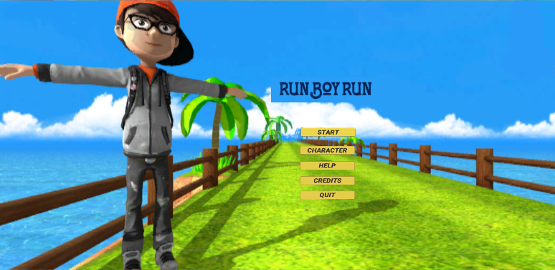

**Figure 8 - Main Menu**

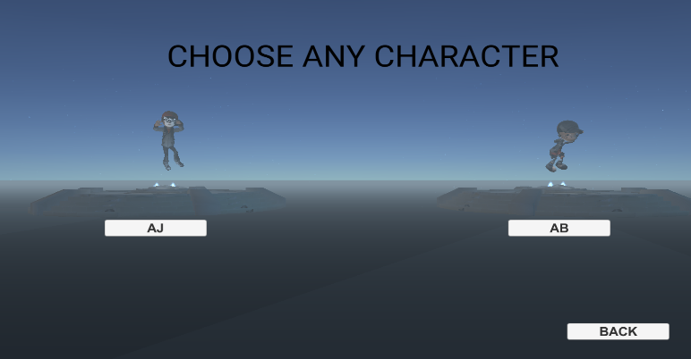By clicking *Select Character* button the player will be prompted to the menu where he/she can select the character he or she wants to play with (Fig. 9)

**Figure 9 - Select Character Menu**

On clicking *Help* the user will proceed to the menu where there will be instructions on how to play (Fig.10)

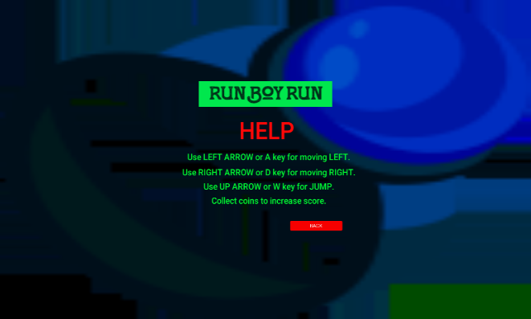**Figure 10 - Help Menu**

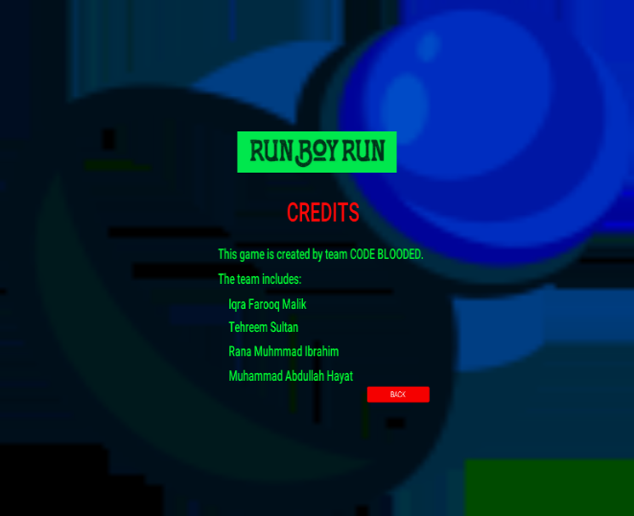Then on clicking the *Credits* button, the user will be directed to the menu where information about the developers of the game is available (Fig. 5)

**Figure 11 - Credits Menu**

The *Exit* button will exit the game.

The main button on *Main Menu* (Fig. 8) is *Start* which will start the game. The core functionalities programmed in the scripts attached with the game objects will now be put into use. The scripts (functions) are described below:

## Player Movement

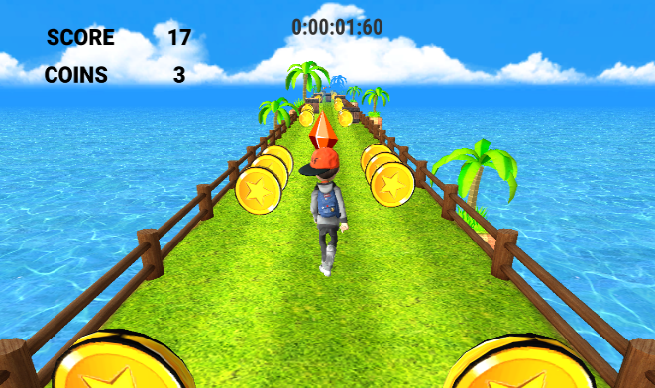This script enables the player to move left, right, forward, and to jump. It turns on the relevant animation according to the movement which player chooses.

**Figure 12 - Running Track**

## Player Collision

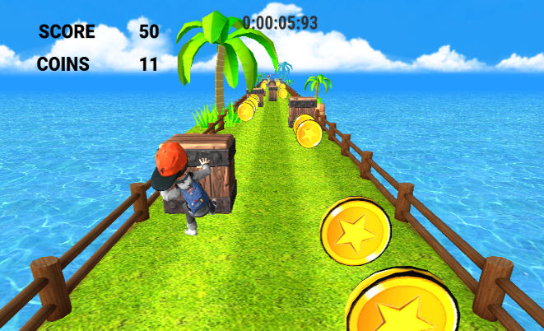When the player collides with an obstacle then this script stops the player movement and kills the player by turning the *fall* animation on and then the game restarts.

**Figure 13 - After Obstacle Collision**

## Bottle Collision

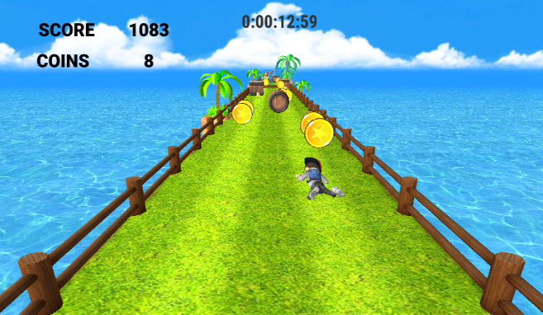When the player collides with bottle then this script comes into work. This script after collision turns on the *drink* and then *die* animation. Then it kills the player and the game restarts.

**Figure 14 - After Bottle Collision**

## Timer

This script counts the time from the start of the game till the present frame and displays this time on the top of the scene in the format *Hours : Minutes : Seconds : MilliSeconds as can be seen in (Fig. 12).*

## Score and Coins

This script counts the score and coins of the player and displays it on the top left corner of the screen. The score is basically the z position of the player. The coins are counted whenever user collides with one. Score and Coin count can be seen in (Fig. 12).

## Power Up

This script comes into work when player collides with a *Diamond.* It increments the score by 1000. (Fig. 15) shows score before collision with diamond and (Fig. 16) shows score after Collision with diamond with an increment of 1000.

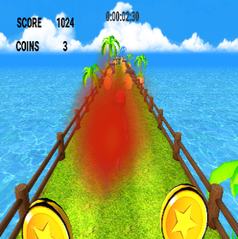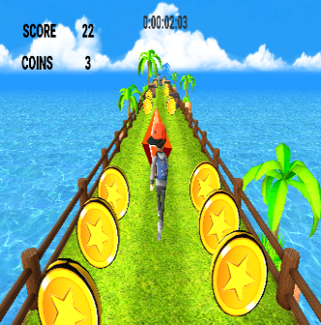

**Figure 15 - After Diamond Figure 16 - Before Diamond**

## Level Complete

This script is activated when the user reaches the end of the level. It enables a UI canvas which congratulates the player on completing the level and then directs player to the next level or, if all the levels are complete then, to the end credits scene.



**Figure 17 - After Completing Level**

# Conclusion

## Summary

The project is based on game development using Unity Engine. We have designed and developed an Obstacle Avoiding 3D game in which the user can move left, right, forward and can jump to avoid various types of obstacles and hence can complete the levels. The game is sufficiently easy and addictive to build user’s interest. During the process, we also learned 3D modelling to design the characters in Blender Software.

## Limitations

The gaming application developed in this project is although very attractive in the interface yet it lacks some features. These features include the choice of a wide range of characters, multiple levels with increasing difficulty levels and increasing types of boosters, the choice of different running tracks or scenes with different background music tracks and lastly, lack of smooth movements of objects and characters due to different frame per seconds of different computers.

## Future Extensions

The limitations described above are something to work on in the future so that the functionalities and features can be extended. The game can be made more attractive, addictive and interesting by including a number of different characters and scenes, boosters and by increasing the number of levels with increasing difficulty level. The game can also be modified to become an endless runner game. Paid assets and features can be used in future to enhance the graphics and interface of the game.

The game can also be modified to work with hand gestures by the use of ultrasonic sensors which work on the principle of reflection of ultrasonic waves. LDR sensors which work on photoconductivity would be a much better choice for sensors as they are more accurate. We can also use hand-wearable sensors such as smart gloves etc.

This game is just a prototype which has the basic features a game must have, but more and more games with different storylines can be developed using the basic functionalities that we learned to develop during this project. Game development is a high demand field of the modern era of computer science, therefore research and work in this field will be very adventurous and vast.

# References

|  |  |
| --- | --- |
| [1] | S. Aleem, L. F. Capretz and F. Ahmed, "Critical Success Factors to Improve the Game Development Process from a Developer’s Perspective," *Journal of Computer Science and Technology,* vol. 31, no. 5, pp. 925-948, September 2016. |
| [2] | K. Annakaisa, "Game design research," in *Academic MindTrek '15*, Tampere, 2015. |
| [3] | Y. Su, "The application of 3D technology in video games," *Journal of Physics: Conference Series 1087 (2018) 062024,* vol. 1087, September 2018. |
| [4] | M. S. El-Nasr and S. Yan, "Visual Attention in 3D Video Games," *Proceedings of the 2006 ACM SIGCHI International Conference on Advances in Computer Entertainment Technology,* vol. 06, July 2006. |
| [5] | A. Indraprastha and M. Shinozaki, "The Investigation on Using Unity3D Game Engine in Urban Design Study," *ITB Journal of ICT,* vol. 3, no. 1, pp. 1-18, 2009. |
| [6] | L. Huang and B. Gui, "Research on the Application of Products based on Unity3D," in *International Symposium on Computers & Informatics 2015 (ISCI 2015)*, Beijing, 2015. |
| [7] | K. Cankova, T. rDovramadjiev and G. Jecheva, "Computer parametric designing in Blender software for creating3D paper models," *ANNUAL JOURNAL OF TECHNICAL UNIVERSITY OF VARNA,* vol. 1, no. 1, pp. 77-84, 28 December 2017. |

# ACKNOWLEDGMENT

This project is made possible through the help of everyone, including family, friends and teachers. Special thanks to course coordinator Miss Zainab and *Association for Computing Machinery (ACM) NED Chapter* for providing access to its library archives.

# AUTHOR’s BIOGRAPHY

*Iqra Farooq Malik* at present, pursuing her Bachelor of Engineering in discipline of Software Engineering from NED University of Engineering and Technology, Karachi, Pakistan. She has worked as a game developer. The domains of her keen interests are game development, robotics and cybersecurity. Presently, she is doing research in the domains of robotics, artificial intelligence and game development.

[iqramalik200021@gmail.com](mailto:iqramalik200021@gmail.com)

+92 306 2942542

*Tehreem Sultan* at present, pursuing her Bachelor of Engineering in discipline of Software Engineering from NED University of Engineering and Technology, Karachi, Pakistan. She has worked as a game developer using Unity Game Engine. The domains of her keen interests are game development and web development. Currently, she is researching in the domain of game development.

[tehreemsultanali@gmail.com](mailto:tehreemsultanali@gmail.com)

+92 333 3135457

*Rana M. Ibrahim* at present, pursuing his Bachelor of Engineering in discipline of Software Engineering from NED University of Engineering and Technology, Karachi, Pakistan. The domains of his keen interests are web development and machine learning. Right now, he is doing research in the domains of artificial intelligence and web development.

[rana.muhammad00@gmail.com](mailto:rana.muhammad00@gmail.com)

+92 307 020492

*Muhammad Abdullah Hayat* is pursuing his Bachelor of Engineering in discipline of Software Engineering from NED University of Engineering and Technology, Karachi, Pakistan. He is associated with the domains of 3D modelling and designing and 2D/3D game development. His domains of interests are modelling and Designing along with 3D game development.

[malik_muhammad222@](mailto:iqramalik200021@gmail.com)outlook.com

+92 303 3906177